Problem1

Problem2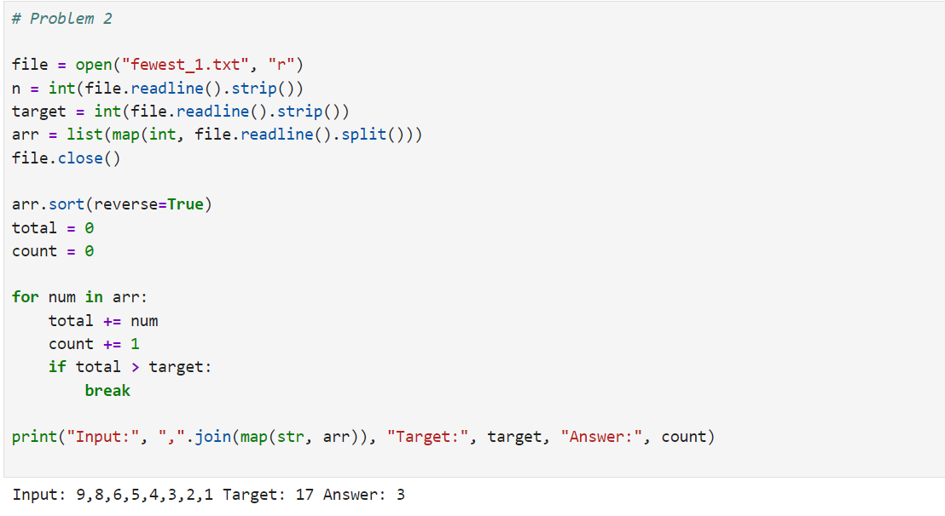
Problem3